1. Write a PHP script to print “hello world”

<?php

echo "Hello World"

?>

**Output:**

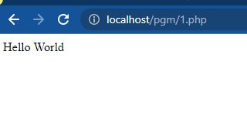

1. WriteaPHPscript tofind oddor evennumber fromgiven number.

<?php

$number=26;

if($number%2==0)

{

echo "$number is Even Number";

}

else

{

echo "$number is Odd Number";

}

?>

**Output:**

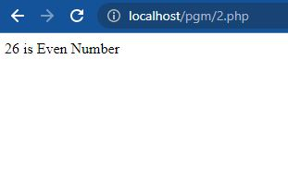

<?php

$number=19;

if($number%2==0)

{

echo "$number is Even Number";

}

else

{

echo "$number is Odd Number";

}

?>

**Output:**

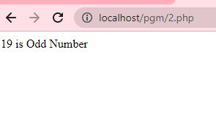

1. WriteaPHPscript to findmaximum of threenumbers.

<?php

**$num1=**50;

**$num2=**40;

**$num3=**20;

**if**(**$num1>$num2** **and** **$num1>$num3**)

{

**echo** "Max is **$num1**";

}

**else if**(**$num2>$num3**)

{

**echo** "Max is **$num2**";

}

**else**

{

**echo** "Max is **$num3**";

}

?>

Output:

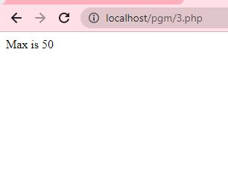

1. WriteaPHPscript toswap two numbers.

<?php

$a = 45;

$b = 78;

echo "Before swapping:<br><br>";

echo "a =".$a." b=".$b ;

// Swapping Logic

$temp = $a;

$a = $b;

$b = $temp;

echo "<br><br>After swapping:<br><br>";

echo "a =".$a." b=".$b;

?>

Without third variable

<?php

$a = 45;

$b = 78;

echo "Before swapping:<br><br>";

echo "a =".$a." b=".$b ;

//using arithmetic operation

$a=$a+$b;

$b=$a-$b;

$a=$a-$b;

echo "<br><br>After swapping:<br><br>";

echo "a =".$a." b=".$b;

?>

Output

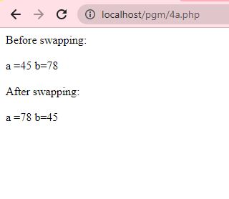

1. WriteaPHPscript tofind thefactorialof a number

<?php

$num = 5;

$factorial = 1;

for ($x=$num; $x>=1; $x--)

{

$factorial = $factorial * $x;

}

echo "Factorial of $num is $factorial";

?>

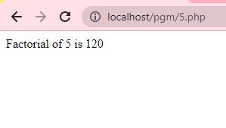

1. WriteaPHPscript tocheckwhether givennumberis palindromeor not

<?php

function palindrome($n){

$number = $n;

$sum = 0;

while(floor($number)) {

$rem = $number % 10;

$sum = $sum * 10 + $rem;

$number = $number/10;

}

return $sum;

}

$input = 123454321;

$num = palindrome($input);

if($input==$num){

echo "$input is a Palindrome number";

} else {

echo "$input is not a Palindrome";

}

?>

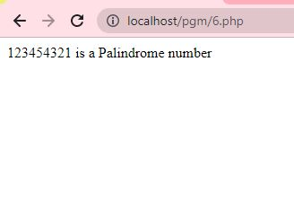 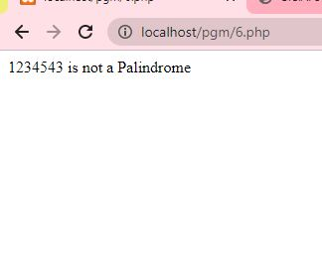

1. WriteaPHPscript toreverseagiven numberandcalculateits sum

<?php

function reverseNumber($number) {

$reversedNumber = 0;

while ($number != 0) {

$digit = $number % 10;

$reversedNumber = $reversedNumber * 10 + $digit;

$number = (int)($number / 10);

}

return $reversedNumber;

}

function calculateSum($number) {

$sum = 0;

while ($number != 0) {

$digit = $number % 10;

$sum += $digit;

$number = (int)($number / 10);

}

return $sum;

}

// Test the functions with a sample number

$number = 123456;

$reversedNumber = reverseNumber($number);

$sum = calculateSum($number);

echo "Original number: $number\n";

echo "<br>Reversed number: $reversedNumber\n";

echo "<br>Sum of digits: $sum\n";

?>

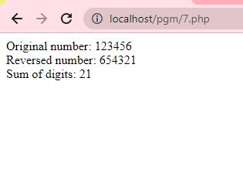

1. WriteaPHP script to generateaFibonacciseries usingRecursive function

<?php

function fibonacci($n) {

if ($n <= 1) {

return $n;

} else {

return fibonacci($n - 1) + fibonacci($n - 2);

}

}

function generateFibonacciSeries($num) {

$fibonacciSeries = array();

for ($i = 0; $i < $num; $i++) {

$fibonacciSeries[] = fibonacci($i);

}

return $fibonacciSeries;

}

// Test the function to generate Fibonacci series

$num = 13;

$fibonacciSeries = generateFibonacciSeries($num);

echo "<b>Fibonacci series of num $num:\n</b><br>";

/* The implode() function in PHP is used to join elements of an array into a single string. It takes two parameters: the separator string and the array to be joined.*/

echo implode(", ", $fibonacciSeries) . "\n";

?>

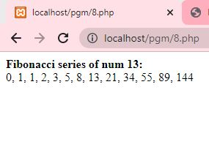

1. WriteaPHP scripttoimplementatleast sevenstringfunctions.

<?php

// String to work with

$string = "Hello, world!";

// 1. strlen(): Get the length of the string

$length = strlen($string);

echo "<br>Length of the string: $length\n";

// 2. strtoupper(): Convert the string to uppercase

$uppercaseString = strtoupper($string);

echo "<br>Uppercase string: $uppercaseString\n";

// 3. strtolower(): Convert the string to lowercase

$lowercaseString = strtolower($string);

echo "<br>Lowercase string: $lowercaseString\n";

// 4. substr(): Get a substring from the string

$substring = substr($string, 0, 5); // Get first 5 characters

echo "<br>Substring: $substring\n";

// 5. str_replace(): Replace part of a string with another string

$newString = str_replace("world", "PHP", $string);

echo "<br>New string after replacement: $newString\n";

// 6. strpos(): Find the position of the first occurrence of a substring in a string

$position = strpos($string, "world");

echo "<br>Position of 'world': $position\n";

// 7. strrev(): Reverse a string

$reversedString = strrev($string);

echo "<br> Reversed string: $reversedString <br>";

?>

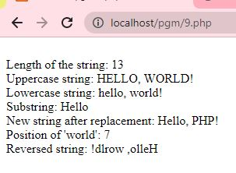

1. WriteaPHP program to insert newitemin arrayon anyposition inPHP.

<?php

//Original Array on which operations is to be perform

$original_array = array( "A","B","C" );

echo 'Original array : ';

foreach ($original_array as $x)

{

echo "$x ";

}

echo "\n";

//value of new item

$inserted_value = "D";

//value of position at which insertion is to be done

$position = 3;

//array_splice() function

array_splice( $original_array, $position, 0, $inserted_value );

echo "<br>After inserting $inserted_value in the array is : ";

foreach ($original_array as $x)

{

echo "$x ";

}

?>

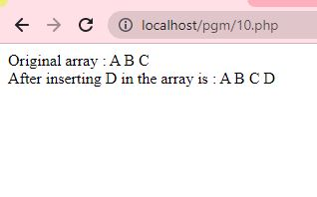

1. Write a PHP script to implement constructor and destructor

<?php

class myclass{

function __construct(){

echo "object is initialized

";

}

function __destruct(){

echo "<br>object is destroyed";

}

}

$obj=new myclass();

?>

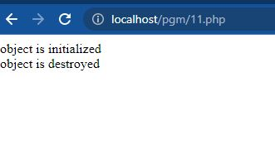

1. WriteaPHPscript to implementform handlingusing get method

/*12.html*/

<html>

<body>

<form action="welcome_get.php" method="GET">

Name: <input type="text" name="name"><br>

E-mail: <input type="text" name="email"><br>

<input type="submit">

</form>

</body>

</html>

/* welcome_get.php*/

<html>

<body>

Welcome <?php echo $_GET["name"]; ?><br>

Your email address is: <?php echo $_GET["email"]; ?>

</body>

</html>

Output

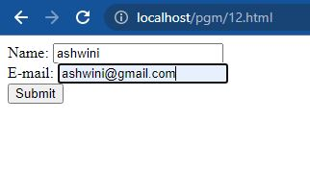

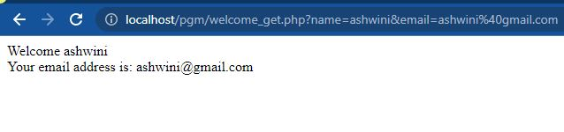

1. Write a PHP script to implement form handling using post method.

/*13.html*/

<html>

<body>

<form action = "posttest.php" method = "post">

Username: <input type = "text" name = "username" /> <br>

Blood Group: <input type = "text" name = "bloodgroup" /> <br>

<input type = "submit" />

</form>

</body>

</html>

/* posttest.php*/

<html>

<body>

Welcome <?php echo $_POST["username"]; ?> </br>

Your blood group is: <?php echo $_POST["bloodgroup"]; ?>

</body>

</html>

Output

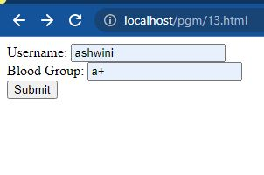

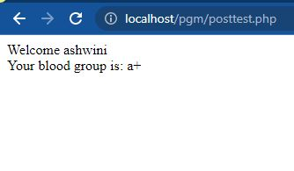

1. WriteaPHPscript that receive form input bythemethod postto check the numberis prime ornot

<html>

<head>

<title>Prime Number Checker</title>

</head>

<body>

<h2>Prime Number Checker</h2>

<form method="post" action="<?php echo htmlspecialchars($_SERVER["PHP_SELF"]);?>">

Enter a number: <input type="text" name="number">

<input type="submit" name="submit" value="Check">

</form>

<?php

// Function to check if a number is prime

function isPrime($num) {

if ($num <= 1) {

return false;

}

for ($i = 2; $i * $i <= $num; $i++) {

if ($num % $i == 0) {

return false;

}

}

return true;

}

if ($_SERVER["REQUEST_METHOD"] == "POST") {

$number = isset($_POST['number']) ? $_POST['number'] : '';

if (is_numeric($number)) {

if (isPrime($number)) {

echo "<p>$number is a prime number.</p>";

} else {

echo "<p>$number is not a prime number.</p>";

}

} else {

echo "<p>Please enter a valid number.</p>";

}

}

?>

</body>

</html>

Output

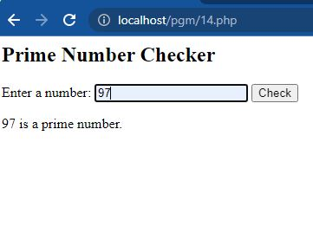

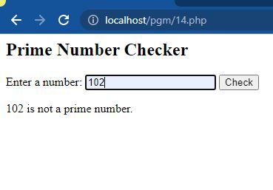

1. **Write a PHP script that receive string as a form input.**

<!DOCTYPE html>

<html>

<head>

<title>Receive String Input</title>

</head>

<body>

<h2>Receive String Input</h2>

<form action="receive_string.php" method="post">

Enter a string:

<input type="text" name="input_string" required>

<input type="submit" value="Submit">

</form>

</body>

</html>

**receive_string.php**

<?php

if ($_SERVER["REQUEST_METHOD"] == "POST") {

// Retrieve string from form input

$input_string = $_POST['input_string'];

// Display the string

echo "You entered: " . $input_string;

}

?>

Output:

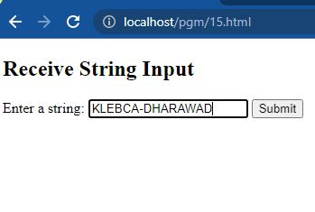

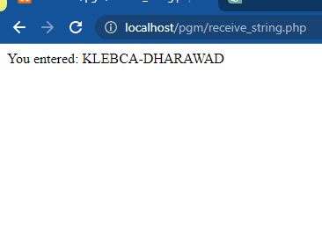

1. **Write a PHP script to compute addition of two matrices as a form input**

﻿ <html>

<head>

<title>Addition of Matrices</title>

</head>

<body>

<h2>Addition of Matrices</h2>

<form method="post" action="<?php echo htmlspecialchars($_SERVER["PHP_SELF"]); ?>"> Enter the number of rows: <input type="number" name="rows" min="1">

Enter the number of columns: <input type="number" name="cols" min="1">

<h3>Matrix A:</h3>

<?php

if ($_SERVER["REQUEST_METHOD"]

$rows = $_POST['rows'];

$cols = $_POST['cols'];

echo '<table>';

"POST") {

for ($i= 0; $i < $rows; $i++) {

echo '<tr>';

for ($j = 0; j < $cols; $j++) {

}

echo '<td><input type="number" name="matrixA[' . $i. ']['. $j. ']" min="0"></td>";

echo '</tr>';

echo '</table>';

}

?>

<h3>Matrix B:</h3>

<?php

if ($_SERVER["REQUEST_METHOD"] == "POST") {

$rows

$_POST['rows'];

$cols = $_POST['cols'];

echo '<table>';

for ($i= 0; $i < $rows; $i++) {

echo '<tr>';

for ($j = 0; j < $cols; $j++) {

}

echo "<td><input type="number" name="matrixẞ[' . $i. '][' . $j . ']" min="0"></td>";

echo '</tr>';

echo '</table>';

<br>

<input type="submit" name="submit" value="Add Matrices">

</form>

<?php

if ($_SERVER["REQUEST_METHOD"] == "POST" && isset($_POST['matrixA']) && isset($_POST['matrix']))

{

$matrixA = $_POST['matrixA'];

$matrixB= $_POST['matrixB'];

function addMatrices ($matrixA, $matrixB)

{

$result = [];

foreach ($matrixA as $i => $row) {

foreach ($row as $j => $value) {

$result[$i][$j] = $value + $matrixB[$i][j];

}

}

}

return $result;

echo "<h3>Resultant Matrix (A + B):</h3>";

echo '<table>';

foreach (addMatrices ($matrixA, $matrixB) as $row) {

echo '<tr>';

foreach ($row as $element) {

echo '<td>. $element. '</td>';

}

echo '</tr>';

}

echo '</table>';

}

?>

</body> </html>

**17.WriteaPHP Script toshow thefunctionalityofdate and time function.**

<?php

$current_datetime date('Y-m-d H:i:s');

echo "Current date and time (UTC): ".$current_datetime. "<br>";

echo "Current date:".$current_date. "<br>";

echo "Current time:".$current_time. "<br>";

$current_day_of_week date('w');

$days_of_week ["Sunday", "Monday", "Tuesday", "Wednesday", "Thursday", "Friday", "Saturday"];

echo "Day of the week: ".$days_of_week [$current_day_of_week]."<br>";

$current_month= date('n');

$months ["January", "February", "March", "April", "May", "June", "July", "August", "September", "October", "November", "December"];

echo "Current month: ". Smonths [$current_month 1]. "<br>";

$current_year = date('Y');

echo "Current year: ".$current_year. “<br>";

?>

**18.Write a PHP program to upload a file**

<html>

<head>

<title>File Upload</title>

</head>

<body>

<h1>write a php program to upload a file</h1>

<form action="" method="post" enctype="multipart/form-data"> Select File:

<input type="file" name="fileToUpload"/>

<input type="submit" value="Upload Image" name="submit"/>

</form>

<?php

if (isset($_POST['submit']))

{

$target_path = "e:/";

$target_path = $target_path.basename( $_FILES['fileToUpload']['name']);

if(move_uploaded_file($_FILES['fileToUpload']['tmp_name'], $target_path))

echo "File uploaded successfully!";

</body> </html>

}

else

{

echo "Sorry, file not uploaded, please try again!";

?>

**19Write a PHP script to implement database creation**

<?php

$servername = "localhost";

$username = "root";

$password = "";

$conn = mysqli_connect($servername, $username, $password);

if (1$conn)

{

}

die("Connection failed: mysqli_connect_error());

// echo "connected successfully";

$sql = "CREATE DATABASE IF NOT EXISTS KLEBCA";

if (mysqli_query($conn, $sql))

{ echo "Database created successfully";

}

else

{ echo "Error creating database:" mysqli_error($conn);

}

mysqli_close($conn);

?>

**20. Write a PHP script to create table**

<?php

$servername = "localhost";

$username = "root";

$password = "";

$database "KLEBCA";

$conn = mysqli_connect($servername, $username, $password, $database);

if (1$conn)

{ die("Connection failed: mysqli_connect_error());

}

// echo "connected successfully";

$sql = "CREATE TABLE IF NOT EXISTS users ( id INT(6) UNSIGNED AUTO_INCREMENT PRIMARY KEY, firstname VARCHAR(30) NOT NULL, lastname VARCHAR(38) NOT NULL, email VARCHAR(58), reg_date TIMESTAMP DEFAULT CURRENT_TIMESTAMP ON UPDATE CURRENT_TIMESTAMP )";

if (mysqli_query($conn, $sql))

{ echo "Table created successfully";

}

else

{ echo "Error creating Table:" mysqli_error($conn);

}

mysqli_close($conn);

?>